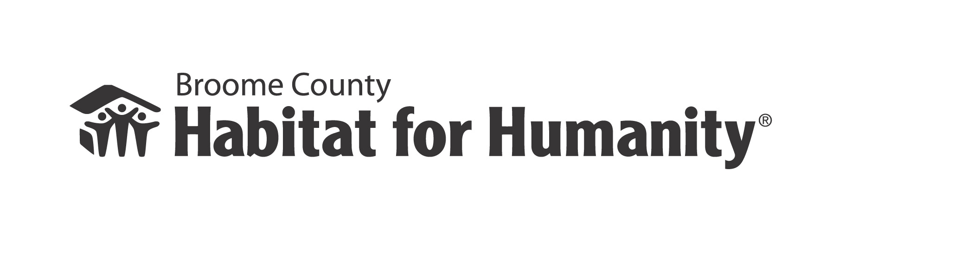
ALSO SERVING TIOGA COUNTY

2018 Family Selection Round
All applications must be returned to the Habitat office. Only complete applications will be accepted.
DUE DATE: ASAP – OPEN APPLICATION ROUND FOR 2018
(If a deadline has been announced, but has passed, you may still apply,
however your application may not be reviewed until our next round is opened.)
Please keep the top two instruction pages for your records.

Dear Applicant,

Habitat for Humanity is a non-profit, faith based organization that is financed through donations to build homes using volunteer labor. Our purpose is to build homes and work with low to moderate income families so that they may successfully qualify for an affordable mortgage. Our goal is to create housing opportunities for those who could not otherwise afford to purchase a home.

- Before completing the application, please read the following items to determine if you have an interest in our program AND to see if you meet our eligibility guidelines.

2. To qualify you must have A NEED FOR HOUSING. Some examples of need include: high utility bills, overcrowding, unsafe or unsanitary conditions, unaffordable rent.

3. You need to have lived in Broome or Tioga County for at least one year. You must be U.S. citizen or a permanent legal resident to qualify for a Habitat home.

4. Selected families are supported in the journey towards the purchase of a home, build by Habitat for Humanity. Partnership families are supported as they seek to qualify for an affordable mortgage, with the ABILITY TO PAY a monthly principal payment along with real estate taxes and homeowner’s insurance. Therefore, regardless of household size, each applicant must have a steady and verifiable monthly income of at least $2,230 or an annual income of at least $26,760. (Maximum amounts see chart below.) Habitat targets families whose income does not fall below 40% or exceed approximately 60% of the average median income (AMI) for Broome and Tioga County. Therefore, your household income must not exceed the income levels below for your family size. Families with income below or above the amounts below are not eligible for Habitat’s partnership program.

2018 Income Guidelines for Broome and Tioga Counties
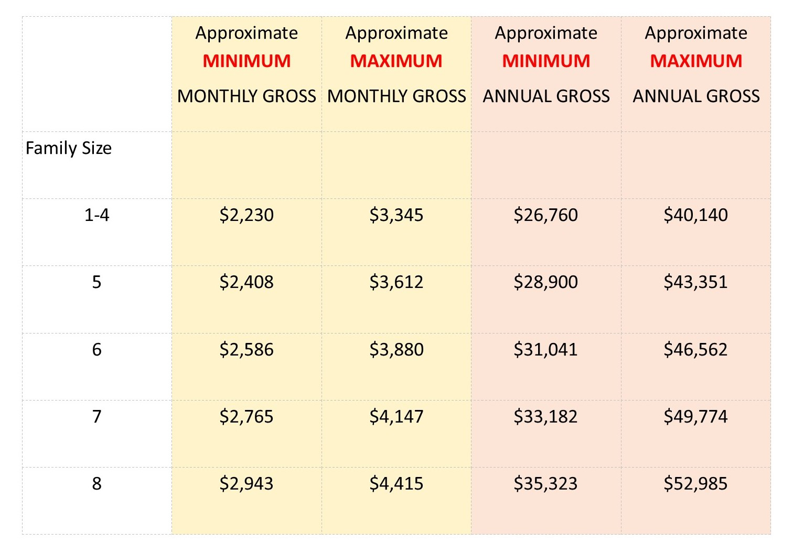

- Habitat is required to verify that applicants fall within the above income guidelines and therefore, applicants must return the following documents with the completed application to be further considered for selection.
- A copy of prior 2 year’s Federal Income Tax Return
- Completed, signed and dated Landlord Verification form
- Completed, signed and dated Employment Verification form
- If you or anyone in your household is receiving benefits from the Department of Social Services (TANF, SNAP, etc.) or Social Security (SSI, SSD, etc.), you must submit a printout of benefits with your application.
- Proof of Citizenship (i.e.Birth Certificate) or Legal Resident Alien Status (Green Card)

- All families who meet Habitat’s income guidelines will be invited via mail to a mandatory Family Selection Information Session to review important applicant information. If you do not attend this session and do not make other arrangements with Habitat’s Director, your application will be declined.

- Criminal Background checks, sex offender registry checks and OFAC (Office of Foreign Assets Control) checks will be done for each applicant prior to consideration for selection as a family partner.

- If you are approved eligibility for a Habitat Family Partnership, we require that you attend budgeting and financial management workshops, as well as home repair and maintenance classes.

- If approved for a Habitat Family Partnership, “sweat equity” volunteer hours must be completed by your household, most of which will be in home construction. If there are 2 adults in your household, the 2nd adult must complete a minimum of 100 hours towards the required 500 hours to ensure that both adults are contributing. Friends and family may also contribute, but the majority of hours must be completed by the applicants.

- If selected for a Habitat Family Partnership, you must make a $500 “in good faith” payment to Habitat with another $2,000 saved during construction for a total of $2,500. These funds will be used toward the future closing costs, should you reach the goal of qualifying for a mortgage for the purchase of a Habitat home. (Each applicant will be guided through the process of applying for First Time Homebuyer funds to potentially cover closing costs, but you must be prepared to pay the closing costs if the First Time Homebuyer funds are not available.) Habitat Family Partnership is not a mortgage offer. The sale of homes are subject to a partnership family’s application for qualified mortgage.

- If you are approved for a Habitat Family Partnership, have completed all the “sweat equity” volunteer hours, and met all the financial obligations, Habitat will assist you in seeking a qualified mortgage with the hope that you are able to purchase one of our safe, affordable homes.

- Habitat for Humanity builds where we receive land donations and current construction plan for the 2018 selection round are for houses built in the City of Binghamton. If you are not willing to live in those areas, you may not want to apply to Habitat’s program at this time. However, it is always possible that new lots or houses could become available.

If you have a WILLINESS TO PARTNER to work towards the goal of home ownership and believe you qualify according to the above guidelines, we encourage you to fill out and return the enclosed application with all required documentation to seek eligibility for Habitat Family Partnership. All information is treated confidentially and is used only for family selection. The application review and selection process can take a few months. Applicants will receive regular communication regarding their application via mail. Please understand that Habitat does not maintain a waiting list. The family/families who best fits the selection criteria will be invited into partnership. If you are not selected, you will be notified by letter and your application will be held for one year. BEST OF LUCK TO YOU!

If you have any questions or need help completing the application,
please call the Habitat office at 239-4783.

We are pledged to the letter and spirit of U.S. policy for the achievement of equal housing opportunity throughout the nation. We
encourage and support an affirmative advertising and marketing program in which there are no barriers to obtaining housing because of race, color, religion, sex, handicap, familial status or national origin.

ALSO SERVING TIOGA COUNTY

- APPLICANT INFORMATION
Applicant Information |  | Co-Applicant Information
Applicant’s name: |  | Co-Applicant’s name:
Social Security Number: |  | Social Security Number:
Home phone number:  Cell phone number:  Work phone number: |  | Home phone number:  Cell phone number:  Work phone number
Email Address: |  | Email Address:
Birth date: Age: |  | Birth date: Age:
How long have you lived in Broome County? |  | How long have you lived in Broome County?
 Married  Separated  Legally Separated   Divorced  Widowed  Single   Other _______________________ |  |  Married  Separated   Legally Separated   Divorced  Widowed   Single   Other _______________________
Current Address : |  | Current Address :
City/State/Zip Code: |  | City/State/Zip Code:
What month & year did you move in to this address? |  | What month & year did you move in to this address?
Landlord Name and phone: |  | Landlord Name and phone:
Landlord Address: |  | Landlord Address:
City/State/Zip Code: |  | City/State/Zip Code:
If you have NOT lived at the above address for at least 2 years,
please list your former address below.
Former Address : | Former Address:
City/State/Zip Code: | City/State/Zip Code:
What month & year did you move in to this address? | What month & year did you move in to this address?
Landlord Name: | Landlord Name:
Landlord Address: | Landlord Address:
City/State/Zip Code: | City/State/Zip Code:
Landlord Phone Number: | Landlord Phone Number:

Please list the names of all members of your current household & their relationship to the Applicant.
Also, list anyone who may live with you if you are selected into the Habitat program.

1. _________________________________ Relationship: _________________ Birth date: ____________M F

2. _________________________________ Relationship: _________________ Birth date: ____________M F

3. _________________________________ Relationship: _________________ Birth date: ____________M F

4. _________________________________ Relationship: _________________ Birth date: ____________M F

5. _________________________________ Relationship: _________________ Birth date: ____________M F

6. _________________________________ Relationship: _________________ Birth date: ____________M F

7. _________________________________ Relationship: _________________ Birth date: ____________M F

8. _________________________________ Relationship: _________________ Birth date: ____________M F

2. WILLINGNESS TO PARTNER

To be considered for Habitat’s FAMILY PARTNERSHIP PROGRAM, the following amount of volunteer hours must be completed by your household:
-1 adult: 350 hours
-2 adults: 500 hours

If there are 2 adults in your household, the 2nd adult must complete a minimum of 100 hours. This is to ensure that both adults are contributing towards construction of Habitat homes and other initiatives.

I am willing to complete the required hours of sweat equity.

Applicant: Yes No Co-applicant: Yes No

- PRESENT HOUSING CONDITIONS

Do you:  Own  Rent
Number of bedrooms (please circle): 1 2 3 4 5

Other rooms:  Kitchen  Bathroom  Living Room  Dining Room  Other: ______________________

If you rent your residence, what is the monthly rent payment? _______________

How much of the rent do you pay? _______________________

How much of the rent is paid by rental assistance? _______________________

If you own your own residence:

What is your monthly mortgage payment? $____________

Unpaid balance $_____________ Approximate value of home $_________________

Do you own any other land?  No  Yes If yes, approximate value: $ ________________

Have you ever owned a home?  No  Yes

Have you ever applied for a mortgage?  No  Yes

3. PRESENT HOUSING CONDITIONS (continued)

- Describe the condition of the house or apartment where you live.

- Explain why you feel you need a Habitat home.

- Does a member of your household have a disability requiring special housing arrangements?
If so, please describe that need.

- What things have you done to try and solve your current housing issues?

- EMPLOYMENT INFORMATION
Applicant Information | Co-Applicant Information
Name of Current Employer: | Name of Current Employer:
Employer’s Address: | Employer’s Address:
Position Held: | Position Held:
City/State/Zip Code: | City/State/Zip Code:
Employer’s Phone Number: | Employer’s Phone Number:
Amount of time at this job: Current wage:  Circle One:  $ per hour  per week  per year | Amount of time at this job: Current wage:  Circle One:  $ per hour  per week  per year

If you have NOT worked at the above job for at least 2 years,
please list your former employer below.
Name of Current Employer: | Name of Current Employer:
Employer’s Address: | Employer’s Address:
Position Held: | Position Held:
City/State/Zip Code: | City/State/Zip Code:
Employer’s Phone Number: | Employer’s Phone Number:
Amount of time at this job: Current wage:  Circle One:  $ per hour  per week  per year | Amount of time at this job: Current wage:  Circle One:  $ per hour  per week  per year

5. MONTHLY INCOME
*Please Enter  Gross Monthly Income | Applicant | Co-Applicant | Others in Household who receive income
Employment Income | $ | $ | $
AFDC/TANF
(cash assistance)
Food Stamps

SSI
Supplemental Security Income
SSD
Social Security Disability
Alimony

Child Support

Other
(worker’s compensation, unemployment, etc)
TOTAL | $ | $ | $

NOTES OR EXPLAINATIONS REGARDING ANY OF THE ABOVE:

6. EXPENSES & DEBT
EXPENSE Monthly  Payment | List all debtors here (vehicles, credit cards, etc)  DEBT Monthly Total  Address of Debtor Payment Balance
Rent: $
Gas/Electric: $
Phone: $
Cable: $
Water: $
Child Care: $
Alimony: $
Child Support: $
Car Insurance: $
Other $
TOTAL $ | TOTALS $ $

7. ASSETS
List all asset information below
Name & Address of Bank or Credit Union:  Account Holder:  Account #: Balance $ | Do you own a car? Yes______ No _______  Car (#1) Make & Year: ______________________________  Car (#2) Make & year: ______________________________
Name & Address of Bank or Credit Union:  Account Holder:  Account #: Balance $ | Please list any other assets you may have:  (retirement account, stocks, bonds, life insurance)  Asset: ________________________ Value: $_______________  Asset: ________________________ Value: $_______________  Asset: ________________________ Value: $_______________

8. SOURCE OF DOWNPAYMENT AND CLOSING COSTS
If approved for a HABITAT FAMILY PARTNERSHIP, you will need to be prepared to apply for a qualified mortgage loan. You will be asked to save approximately $2,500 during your partnership and application process to be used toward the closing costs of your home. Each applicant will be guided through the process of applying for a mortgage and First Time Homebuyer funds to cover these costs, but must be prepared to pay the closing costs if the First Time Homebuyer funds are not available.

If you are success in applying for a qualified mortgage loan, how do you plan to cover your down payment and closing costs?

9. DECLARATIONS
Please check the box that best answers the following questions for you and the co-applicant.
 | Applicant | Co-Applicant
a. Do you have any debt because of a court decision against you? | ❑ Yes  No | ❑ Yes  No
b. Have you declared bankruptcy within the past 7 years? | ❑ Yes  No | ❑ Yes  No
c. Have you had property foreclosed on in the last 7 years? | ❑ Yes  No | ❑ Yes  No
d. Are you currently involved in a lawsuit? | ❑ Yes  No | ❑ Yes  No
e. Are you paying alimony or child support? | ❑ Yes  No | ❑ Yes  No
f. Are you a U.S. citizen? | ❑ Yes  No | ❑ Yes  No
g. Are you a legal permanent resident? | ❑ Yes  No | ❑ Yes  No
If you answered “yes” to questions a-e, please explain below.

10. AUTHORIZATION & RELEASE

I understand that by filing this application, I am authorizing Broome County Habitat for Humanity to evaluate my actual need for a Habitat home, my ability to repay a qualified mortgage loan, and my willingness to be a partner with Habitat. I understand that the evaluation may include a personal home visit, a credit check, criminal background check and OFAC check. There will be verification of my income, my current housing situation, and other financial obligations.

In signing this application, I give my written permission for Broome County Habitat for Humanity to verify all information supplied and I authorize all persons and organizations listed to release this information to Habitat for Humanity for purposes of evaluating my application.

I have answered all the questions on this application truthfully. I understand that if I have not answered the questions truthfully, my application may be denied, and that even if I have already been selected for HABITAT FAMILY PARTNERSHIP, I may be disqualified from the program. The original or a copy of this application will be retained by Broome County Habitat for Humanity even if the application is not approved, for 3 years.

At this stage of the application process, agencies that may need to assist in verifying your application information and thus are authorized in this release are:

FAMILY SELCTION COMMITTEE, BROOME COUNTY HABITAT FOR HUMANITY
NBT Bank
METRO INTERFAITH
NEW YORK STATE HABITAT FOR HUMANITY

Applicant Signature Co-Applicant Signature

x_____________________________________ x_____________________________________

Date ______________________ Date ______________________

Request for Landlord Verification and Reference

Applicant: ________________________________________ Date: ________________

To whom it may concern:

The above named person(s) has applied for a FAMILY PARTNERSHIP through Broome County Habitat for Humanity, a nonprofit organization providing affordable housing to low and moderate income families. This process can take up to one year to complete. As their landlord, we would like you to verify their payment history as renters.

For the 2018 Round, applicants will need this form back to include in their application packet.
Please call the Habitat office with any questions at 239-4783.

Sincerely,
The Family Selection Committee

Rental period: (please give dates)

From _____________________to ___________________

Amount of monthly rent: $________________
Amount paid by applicant: $________________
Amount paid by rental assistance: $ _______________

Applicant’s payment history: (please circle one)

Excellent Satisfactory Unsatisfactory

Additional Comments:

Landlord Signature Date

Please print your name, address and phone number should we need to contact you:

___________________________________________________________________________________

____________________________________________________________________________________

Notice: The federal Equal Credit Opportunity Act prohibits creditors from discriminating against credit applicants on the basis of race, color, religion, national origin, sex, marital status, age (provided the applicant has the capacity to enter into a binding contract); because all or part of the applicant’s income derives from any public assistance program; or because the applicant has in good faith exercised any right under the Consumer Credit Protection Act. The federal agency that administers compliance with this law concerning this creditor is the Federal Trade Commission, Washington, DC 20580.

Request for Employment Verification

Applicant: ____________________________________________________ Date: ___________

To whom it may concern:

The above named person(s) has applied for a FAMILY PARTNERSHIP through Broome County Habitat for Humanity, a nonprofit organization providing affordable housing to low and moderate income families. This process can take up to one year to complete. As their employer, we would like you to verify their employment history with you and their income.

For the 2018 Round applicants will need this form back to include in their application packet.
Please call the Habitat office with any questions at 239-4783.

Sincerely,
The Family Selection Committee
___________________________________________________________________________________

Verification Information

Name of employer: _____________________________________________________

Address and Phone of employer: ____________________________________________

Dates of employment: from _____________________to ________________________

Present position: _________________________________________________________

Current base pay: $__________/________ Overtime pay: $___________/__________

Hours worked per week: ________ Average overtime hours per week: _______

Additional Comments:

Employer signature Date

Notice: The federal Equal Credit Opportunity Act prohibits creditors from discriminating against credit applicants on the basis of race, color, religion, national origin, sex, marital status, age (provided the applicant has the capacity to enter into a binding contract); because all or part of the applicant’s income derives from any public assistance program; or because the applicant has in good faith exercised any right under the Consumer Credit Protection Act. The federal agency that administers compliance with this law concerning this creditor is the Federal Trade Commission, Washington, DC 20580.

Request for Social Security Benefits Verification

Applicant: ___________________________________________________________________

Date: _______________________ SS#: _______________________

To whom it may concern:
The above named person(s) has applied for a FAMILY PARTNERSHIP through Broome County Habitat for Humanity, a nonprofit organization providing affordable housing to low and moderate income families. This process can take up to one year to complete. We need to verify all Social Security benefits for this person and/or his or her household.

Please complete the form below and include a print out for proof of benefits as approved.
For the 2018 Round, applicants will need this form back to include in their application packet.
Please call the Habitat office with any questions at 239-4783.
______________________________________________________________________________________

Verification Information

Recipient(s): ___________________________________________________________________

Monthly amount received for: $ _________ SSI $_________ SSD

Expected Duration: ______________________________________________________________

Has the family faithfully represented their income to your since they have been receiving these benefits? ____

When are these benefits up for review? _______________

If this client /applicant buys a home, will this asset affect these benefits? _______
Will home be subject to a lien or second mortgage by your agency? ________ (If yes, please explain.)

Signature Title Date

Please print your name and phone number in case we need to contact you:

______________________________________________________________________________

Notice: The federal Equal Credit Opportunity Act prohibits creditors from discriminating against credit applicants on the basis of race, color, religion, national origin, sex, marital status, age (provided the applicant has the capacity to enter into a binding contract); because all or part of the applicant’s income derives from any public assistance program; or because the applicant has in good faith exercised any right under the Consumer Credit Protection Act. The federal agency that administers compliance with this law concerning this creditor is the Federal Trade Commission, Washington, DC 20580.

Request for Social Services Benefits Verification

Applicant: ____________________________________ Date: _______________________
SS#: _________________________

To whom it may concern:
The above named person(s) has applied for a FAMILY PARTNERSHIP through Broome County Habitat for Humanity, a nonprofit organization providing affordable housing to low and moderate income families. This process can take up to one year to complete. We are contacting you for verification of all Social Services benefits for this person and/or his or her household.

Please complete the form below and include a print out for proof of benefits as approved.
For the 2016 Round, applicants will need this form back to include in their application packet.
Please call the Habitat office with any questions at 239-4783.
_________________________________________________________________________________________

Verification Information

Monthly amount received for:

$ __________ TANF $ __________ Food stamps

$ __________ Child support (if court ordered) $ __________ Rental assistance

Has the family faithfully represented their income to your since they have been receiving these benefits? ____

When are these benefits up for review? _______________

If this client /applicant buys a home, will this asset affect these benefits? _______ Will home be subject to a lien or second mortgage by NYS DSS? ________

Signature Date

Please print your name and phone number in case we need to contact you:

______________________________________________________________________________

Notice: The federal Equal Credit Opportunity Act prohibits creditors from discriminating against credit applicants on the basis of race, color, religion, national origin, sex, marital status, age (provided the applicant has the capacity to enter into a binding contract); because all or part of the applicant’s income derives from any public assistance program; or because the applicant has in good faith exercised any right under the Consumer Credit Protection Act. The federal agency that administers compliance with this law concerning this creditor is the Federal Trade Commission, Washington, DC 20580.

